**BARCELONA CITY ONTOLOGY**

**(UMBRELLA MODEL)**

**SUMMARY**

1. INTRODUCTION 3

1.1 Context 3

2. ONTOLOGY DESIGN METHODOLOGY 4

3. SITUATION STATUS 6

3.1 Context analyzing 6

3.2 Information provided 6

4. DESIGN OF BARCELONA ONTOLOGY 11

4.1 Reused Ontology 11

City anatomy ontology 11

Schema.org ontology 12

SEAS Ontology 12

Geometry and geolocation ontology 12

Time ontology 14

4.2 Barcelona City Ontology 14

Method used according to information and the situations 14

Generic built domain element 16

Administrative built domain element 16

Physical built domain element 18

Network infrastructure 19

Mobility Network 20

Network infrastructure component 21

Mobility network component 23

More other categories 24

5. ONTOLOGY METRICS 26

6. ONTOLOGY COMPETENCY QUESTIONS 27

7. CONCLUSION 31

# introduction

## Context

The city of Barcelona, as other cities in the world, would like to become a "smart city". A smart city can be defined as "***A developed urban area that creates sustainable economic development and high quality of life by excelling in multiple key areas; economy, mobility, environment, people, living, and government. Excelling in these key areas can be done so through strong human capital, social capital, and/or ICT infrastructure.***"[1]

An other definition is ***a smart city is an urban development vision to integrate information and communication technology (ICT) and Internet of things (IoT) technology in a secure fashion to manage a city’s assets. These assets include local departments’ information systems, schools, libraries, transportation systems, hospitals, power plants, water supply networks, waste management, law enforcement, and other community services.*** [2]

In order to fulfill these goals, the city of Barcelona has established a number of projects that can be considered "smart city’s" applications within its "CityOS" strategy. The goal of these projects was to have a global view on the data, infrastructure and platforms existing in the city in order to provide more interoperability and interactions between these different elements.

The city anatomy protocol was one of these projects which designs an ontology to ensure the objectives. Indeed, using knowledge representation and knowledge reasoning with ontology engineering is one of the best approaches to represent knowledge in a domain and it is the angular stone to ensure interoperability between heterogeneous platforms.

The city of Barcelona consider that the territory can be described and formalized with four core concepts.

1. **Entity**: Can be individual human being or non-individual human being

2. **Time**: dimension in which things continue to exist. the moment in which something to happen

3. **Location**: A space where something or someone can sit, be placed, etc.

4. **Activity**: Categories of Activity defined by Barcelona City: Culture, Economy, Sport, etc.

The city of Barcelona wants to be able to describe situations where entities are participating in an activity in a certain location at a specific interval of time. In this report, we describe the methodology used to design an ontology for Barcelona City.   
 First, in section 2 we start to describe briefly one methodology usually used to design ontologies. Unfortunately we did not have all required elements to follow correctly this method. We briefly describe, in section 3 the actual situation and the resource we had to build the ontology. Then, in section 4 we describe our approach followed to design the ontology. In section 4.1, we start by citing the ontologies reused or should be reused. Then, we present the result of the design process in section 4.2. Finally, we give some metrics (section 5) and some interesting competency questions (section 6). At the end, we finish with a conclusion and provide some perspectives.

# ONTOLOGY DESIGN METHODOLOGY

There are several methodologies to develop ontology. Choosing a specific methodology over another one depends on multiple criteria (i.e. availability of data, etc.) and of course, what kind of USE CASE, global context is addressed. We strongly emphasize that there is no generic methodology to design an ontology. The purpose of ontology is also a major element to choose the methodology to design an ontology. In our case we choose the following methodology, where we have to follow some main steps:

1. **Scope delimitation**: Delimiting the scope and the domain of the ontology is a very important step in ontology designing process. Because we can note describe "everything" in the world in one ontology; we must delimit its scope. Among methods to delimit the scope we can use:

• **Scenarios Description**: is one method to know what the ontology must cover. The scenarios must be described in detail to know the level of knowledge the ontology has to represent. For example, it is different in the design of the ontology between one scenario where we need to represent the global activities of the city from the scenario where we want to know the specific activities for each individual and the spatial location and temporal frame of these activities.

• **Competency questions CQ**: are a natural language sentences that express a pattern for a type of questions for which people expect that an ontology will help to provide the best answer. The *answerability* of CQs becomes then a functional requirement of the ontology. Examples of competency questions could be

(a) Which are all health care structures located in the city?

(b) Is this hospital public or private?

(c) When it was built? What kind of patient is treated?

(d) What is the nearest hospital from my position?

(e) What is the distance between each two primary schools?

(f) Does the city has any university?

Note that the list of the CQ does not must be exhaustive and can be completed in the ontology design (iteration) process.

2. **Concepts and relations identification**: From the competency questions, the scenario description and the domain of the discourse of the targeted ontology, we can identify a list of concepts and relations which may relate these concepts. Some main questions that we try to answer are

• What are the concepts we would like to talk about?

• What properties do those concepts have?

• What would we like to say about those concepts?

3. **Reusing existing ontology**: It is almost always worth considering what someone else has already done and checking if we can refine and extend existing sources for our domain and tasks. Reusing existing ontologies may be a requirement if our system needs to interact with other applications that have already committed to specific ontologies or controlled vocabularies. Many ontologies are already available in electronic form and can be imported into an ontology-development environment that you are using

4. **Build a taxonomy**: consists in building a class hierarchy by defining top level concepts that are generic enough which are specialized with mid-level concepts until to defining bottom level concepts. We can use top-down level approach, bottom-up approach or a combination of the two approaches. According to the need of the ontology and the person who design the ontology the approach chooses may be different.

5. **Try to reach a consensus**: ontology is generally designed to share knowledge in a domain. So, for that, it is important that the domain experts reach an agreement on the meaning and definition given to the concepts and the hierarchy proposed. This agreement will encourage the reusing of the ontology in other projects.

6. **Ontology population**: consists of creating the instances corresponding to the concepts and relating these instances with relations or data values. For instance, below we declare the individual **ex:spain** as an instance of the concept **cao:Country**, and we declare **ex:barcelona** as an instance of the concept **cao:City** and **ex:catalonia** as an instance of the concept **Autonomous_community**. Then we link **ex:catalonia** to its capital **ex:barcelona** with the relation ***hasCapital***, and add the link to it location **ex:spain** with the relation ***isLocated***.

@Prefix bco: <http://www.example.org/ontologies/BarcelonaCityOntology#>.

@Prefix cao: <http://www.biocenit.cat/ontologies/city_anatomy/CA.owl#>.

@Prefix ex: <http://www.example.org/resource/>.

ex:spain a cao:Country.

ex:barcelona a cao:City.

ex:catalonia a bco:Autonomous_community;

bco:hasCapital ex:barcelona;

cao:isLocated ex:spain.

7. **Formulate CQ with SPARQL**: After populating the ontology with instances, we can check that the ontology is able to answer competency questions defined previously. For that we must express these questions with SPARQL query. For example, for the question: "What is all health care structures located in the City?"

Prefix bco <http://www.semanticweb.org/ontologies/BarcelonaCityOntology#>

Prefix cao <http://www.biocenit.cat/ontologies/city_anatomy/CA.owl#>

SELECT *

WHERE{

?healthcarInstitution a bco:Healthcare_institution;

a?type;

cao:isLocated data:Bercelona.

}

8. **Evaluate and Validate**: consists of the process of testing and checking the validation of the data generated with the ontology.

# situation status

In the previous section, we describe the methodology usually used to design an ontology. However, for our case, we unfortunately don’t have any elements like scenario description or competency questions. We don’t have either any extracts of data neither access to experts to describe what is the need of the ontology. Instead of that, we had:

• Excel files listing table names in Catalan

• Schemas of tables with a lot of abbreviations in column name (ex: ZRP, ZEG, AEB, ABS,..)

• An UML model without providing the meaning of the link between tables

• No definition of concepts are provided

## Context analyzing

After analysing the core concepts identified by the city of Barcelona, we noticed the following

1. **Entity**: this concept is too generic and too large in the ontological point of view. Entity could be anything in the world. It may be a person, a building, a city, an idea, a project etc. So this concept should be specialized to meet the need of Barcelona City.

2. **Time** : This concept is generic for all domain. It is not specific to our ontology. Then we reuse existing ontology .

3. **Location**: is generally used to express the location of something in some place, space or zone. We will express this information by linking two entities with the location information. For example, **Barcelona** *isLocated* **Spain**

4. **Activity**: are activities defined by Barcelona City, among them we can cite sport, economy, tourism, culture, etc.

## Information provided

Below is the list of files provided by the client.

1. **Cataleg dades Situation room.0_1**: this file contains a list of tables name in catalan (see the figure  1 ).

2. **CTDB_Object inicial.0_1**: this file also contains a list of table names (See the figure  2).

3. **Model.0_1**: this file contains un UML about territory information. However, there are not any information given to explain the significations of the row drawn between the tables (See figure  3).

4. **Taules DWH Dim Territorial i Temporal.0_1**

5. **Volumetria v2.0_1** this file contains some volumetrics value. But, it was not helpful for our ontology.

6. **Componentes Sentilo** and **Sensores Sentilo**: these two files contain information about some sensors and about some measurable properties (see figures 5 and 6 ).

Figure 1: Extract of the situation room file

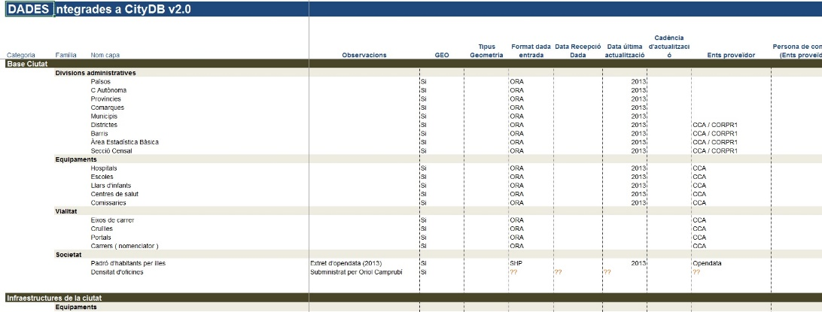

Figure 2: Extract of CTDB object file

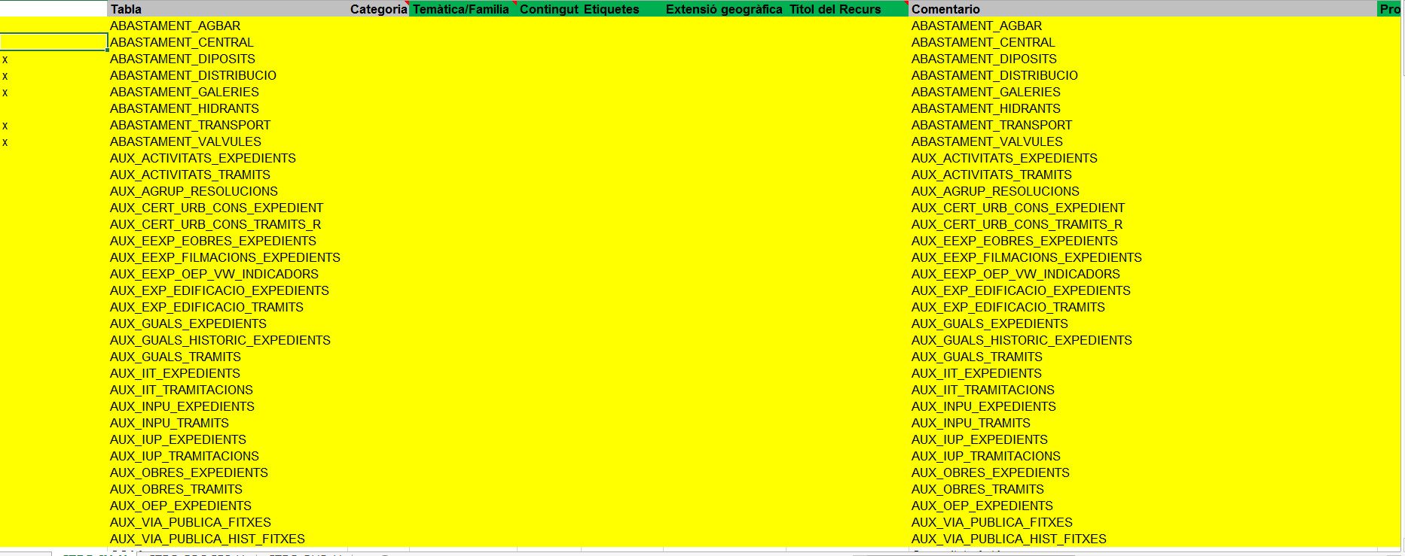

Figure 3: Extract of the UML model

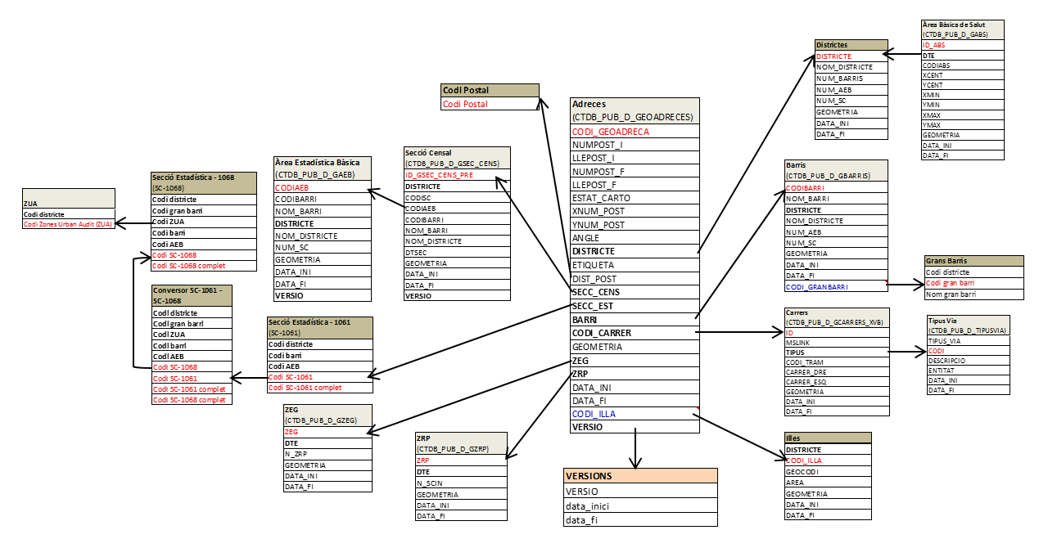

Figure 4: Extract of territory schema

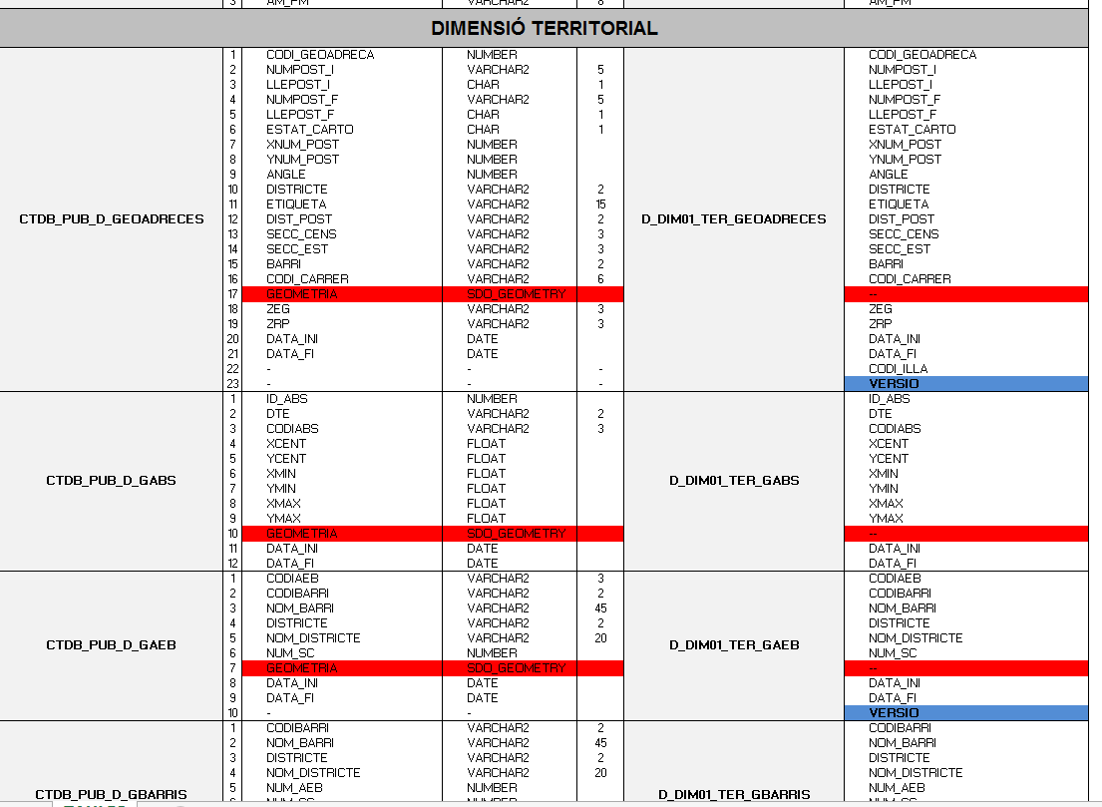

Figure 5: Extract of components sentilo file

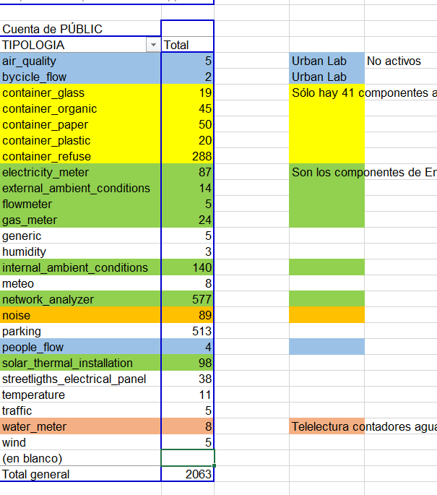

Figure 6: Extract of sensores sentilo file

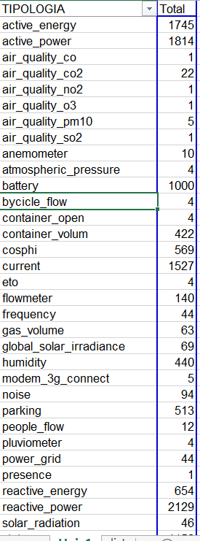

# design of barcelona ontology

Because no competency questions were defined neither scenarios described, we had to start the work on ontology designs by using the different files provided by the client. As we have only list of names of table, we start on analysing these table name and try to represent the concept corresponding to the table name. A phase of translation from Catalan to English was made before because the concept on the ontology should be in English

The client wants to develop what that he calls an ***Umbrella ontology***. This term is not frequently used in ontologies’ domain of discourse. Actually, we did not succeed in finding any definition about it. It will be very useful to have a precise functional definition with expectation of the ***Umbrella Ontology***. However, terms which are close to this meaning could be an  ***upper level ontology*** or ***domain ontology*** to describe a generic level in the ontology. The client wants to have a high-level ontology to be able to specialize it, to describe more specific concepts. Before starting to develop, the ontology we have considered the potential existing ontologies relevant to our case. The next section resume the reused ontologies.

### 4.1 Reused Ontology

#### City anatomy ontology

After analysing the list of table names given by the client and the vision of the client to describe Infrastructure, Interactions and Society. We decide to reuse the city anatomy ontology as a foundational ontology for city [3]. This choice is oriented because the city anatomy ontology already address these issues and design an ontology to describe the city as a System of Systems, which can interact. These Systems are organized as Systems layers which are formed by system layers’ components. Systems are specialized as Structure, Interactions and Society. Figure 7 shows these upper level concepts [4].

Figure 7: System of system city anatomy ontology

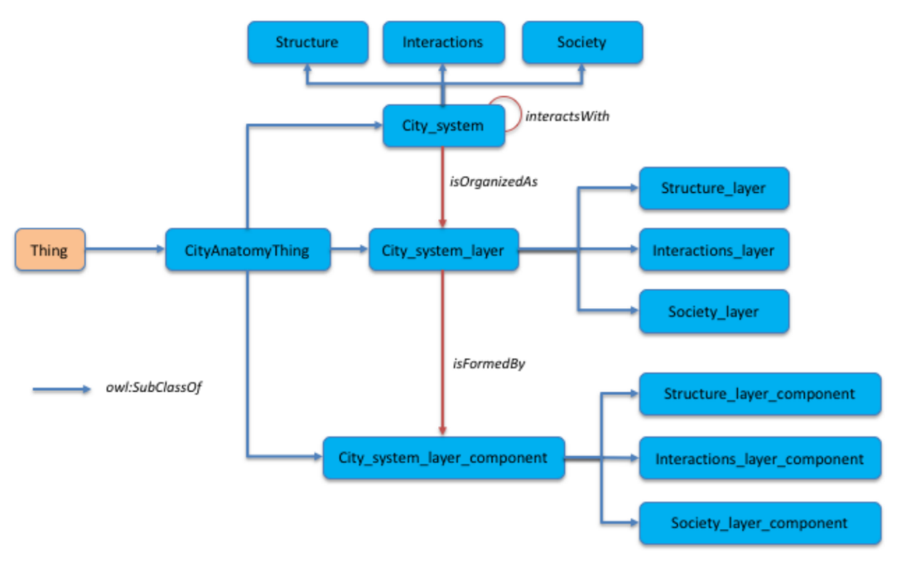

Note that it is important to be aware of the city anatomy ontology to understand the frame work and the potential of our ontology. Basically, the process used is to identify concepts from the files provided and extends the right concepts in the city anatomy ontology. For example, **Bus network** extends the concept **Mobility network**.

#### Schema.org ontology

Schema.org[5] is reused by city anatomy ontology to represent the concept of **Place**, **Person** and **Organization** and other things like **Role**, **PostalAddress**. In city Barcelona ontology, we also extend some concepts from schema.org. For example, **Intangible** was extended to represent concepts like **Nomenclature_of_Territorial_Units_for_Statistics** **ISO_Norm**, and **PostalCode**

#### SEAS Ontology

The evaluation module of the SEAS ontology[6] is reused essentially to represent measures of properties, like temperature, humidity, length. These properties are inherent in a unique entity. They can be measured at different times and get values. Evaluation ontology allows to describe these evaluations in terms of temporal context, spatial context, and the value obtained (see figure  8 [7]).

Below an example of an evaluation of a temperature property:

@prefix <https://w3id.org/seas/>

<air/temperature> a seas:TemperatureProperty;

seas:evaluation [

a seas:TemperatureEvaluation , seas:exactEvaluation;

prov:wasGeneratedBy <algorithm/1/execution/234> ;

prov:generatedAtTime "2016-08-12T12:00:00Z"^^xsd:dateTime ;

seas:hasTemporalContext [ a time:Instant ;

time:inXSDDateTime "2016-08-13T12:00:00Z"^^xsd:dateTime ] ;

seas:hasSpatialContext [ a geo:Point ;

geo:lat 45.7242502 ;

geo:long 5.0914517 ] ;

seas:evaluatedSimpleValue "28.3 C"^^cdt:ucum ] .

Figure 8: Evalaution module of the SEAS ontology

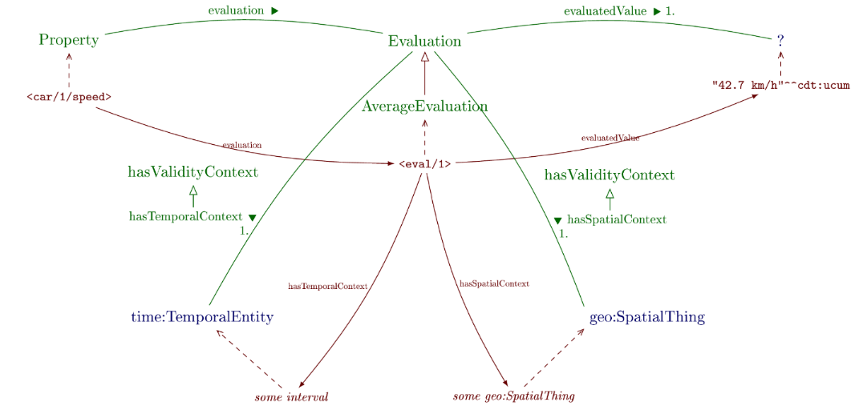

Furthermore, the seas ontology defines some concepts needed in the city Barcelona ontology. We think that it is worth making links between them. Examples already made are the *owl:equivalentClass* link between the **seas:Sensor** and **bco:Sensor** and **seas:ElectricVehicleChargingStation** and **bco:Electric_vehicle_charging_station** concepts.

#### Geometry and geolocation ontology

For information about geometry and the geolocation we reused the two following ontologies

GeoSPARQL ontology[8] to describe the geometry of a spatial object. Below an example that describes a geometry for two objects.

@prefix owl: <http://www.w3.org/2002/07/owl#> .

@prefix rdfs: <http://www.w3.org/2000/01/rdf-schema#> .

@prefix geo: <http://www.opengis.net/ont/geosparql#> .

@prefix ex: <http://www.example.org/POI#> .

@prefix sf: <http://www.opengis.net/ont/sf#> .

ex:WashingtonMonument a ex:Monument;

rdfs:label "Washington Monument";

geo:hasGeometry ex:WMPoint .

ex:WMPoint a sf:Point;

geo:asWKT "POINT(-77.03524 38.889468)"^^geo:wktLiteral.

ex:NationalMall a ex:Park;

rdfs:label "National Mall";

geo:hasGeometry ex:NMPoly .

ex:NMPoly a sf:Polygon;

geo:asWKT "POLYGON((-77.050125 38.892086,

-77.039482 38.892036,

-77.039482 38.895393,

-77.033669 38.895508,

-77.033585 38.892052,

-77.031906 38.892086,

-77.031883 38.887474, -

77.050232 38.887142,

-77.050125 38.892086 ))"^^geo:wktLiteral.

Another advantage in using this ontology is that we will be able to make geospatial reasoning on data described. An example of geosparql query could "Which monuments are spatially within which parks?"

PREFIX geo: <http://www.w3.org/2003/01/geo/wgs84_pos#>

PREFIX ex: <http://www.example.org/POI#>

SELECT ?m ?p

WHERE {

?m a ex:Monument ;

geo:hasGeometry?mgeo .

?p a ex:Park ;

geo:hasGeometry?pgeo .

?mgeo geo:sfWithin?pgeo .

}

In other side we can reuse W3C geolocation ontology [9] to describe longitude and latitude property for some location un example is

@prefix bco: <http://www.example.org/bco#>

@prefix bco: <http://www.example.org/bco#>

@prefix rdfs: <http://www.w3.org/2000/01/rdf-schema#>

@prefix ex: <http://www.example.org/bco/data#>

@prefix geo: <http://www.w3.org/2003/01/geo/wgs84_pos#>

ex:hospitalSantJoan a bco:Hospital;

rdfs:label "Hospital Sant Joan de Deu Barcelona"@en;

geo:location ex:location.

ex:location a geo:Point;

geo:long "2.102088"^^xsd:double;

geo:lat "41.384537"^^xsd:double.

#### Time ontology

The OWL-Time ontology[10] is an OWL-2 DL ontology of temporal concepts, for describing the temporal properties of resources in the world or described in Web pages. The ontology provides a vocabulary for expressing facts about topological relations among instants and intervals, together with information about durations, and about temporal position including date-time information. Figure 9 shows the main concepts and predicates defined in the Time ontology [11].

Figure 9: The main classes and properties in the Time Ontology

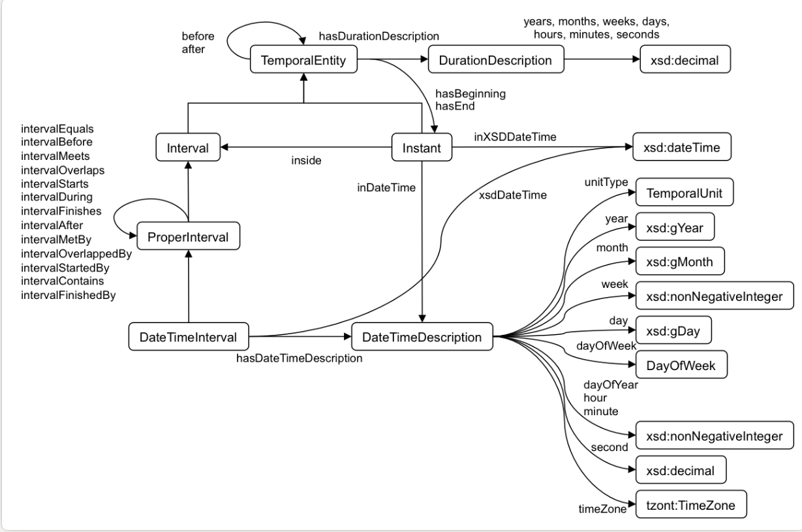

### 4.2 Barcelona City Ontology

#### Method used according to information and the situations

Because not competency questions were defined, we start our work based on the file Cataleg dades Situation room.0_1.xsl. This file was served to identify the concepts. So we follow the steps described here (see the figure 10):

1. Using Cataleg dades Situation room.0_1.xsl to extract the concepts

2. Translating concepts from Catalan into English

3. Check if the concept already exists in cityProtocol (Green cell)

4. Add the concept under the right concept, if it is clear (Yellow cell)

5. If the concept is not clear, it is not added (Red cell)

6. Add concepts that specialize other ontologies (Orange cell)

7. Add more generic/more specific concept if it is possible and relevant

Figure 10: Processed room situation file

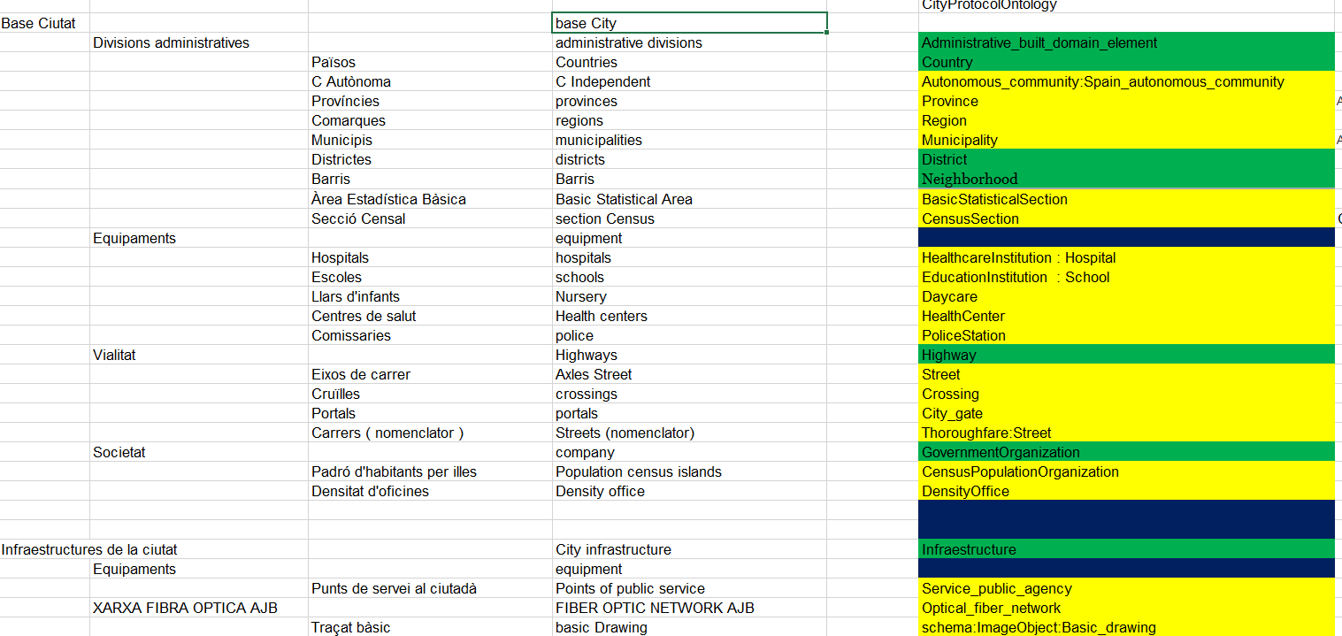

#### Generic built domain element

In the list of the table name and the model we found several concepts which are in the built domain. the table 1 shows the concepts belong to generic built domain.

|  |  |  |
| --- | --- | --- |
| Class | Property | Value Restriction |
| Beach | *owl:subClassOf* | cao:Generic_built_domain_element |
| 2*Continent_group | *owl:subClassOf* | cao:Generic_built_domain_element |
|  | *cao:hasElement* | **some** cao:Continent |
| Island | owl:subClassOf | cao:Generic_built_domain_element |
| 2*Island_group | *owl:subClassOf* | cao:Generic_built_domain_element |
|  | *cao:hasElement* | **some** Island |
| Flooding_zone | *owl:subClassOf* | cao:Generic_built_domain_element |

Table 1: Concepts belong in the Generic built domain element

#### Administrative built domain element

Administrative built domain elements are concept related to the administrative division made by the authority to delimit and identify some places. For example, Country is not a natural concept but correspond to an artificial delimitation decided by the authority. Below are all, concepts found in the different files that belong to the administrative built domain element. (see the table 2)

|  |  |  |
| --- | --- | --- |
| Class | Property | Value Restriction |
| 2*cao:Administrative_built_domain_element | *owl:subClassOf* | cao:Specific_domain_element |
|  | *geo:hasGeometry* | **some** geo:Geometry |
| 2*Autonomous_community | *owl:subClassOf* | cao:Administrative_built_domain_element |
|  | cao:isLocated | **exactly 1** cao:Country |
| 6*Spain_autonomous_community | *owl:subClassOf* | Autonomous_community |
|  | *hasCapital* | **some** Capital |
|  | *cao:isConstituent* | **some** Province |
|  | *isPartOf* | **value** dbr:Spain |
|  | *owl:equivalentClass* | Autonomous_community |
|  |  | isLocated value dbr:Spain |
| Capital | *owl:subClassOf* | cao:City |
| 2*cao:Country | *owl:subClassOf* | cao:Administrative_built_domain_element |
|  | *hasCapital* | **some** Capital |
| 2*cao:District | *owl:subClassOf* | cao:Administrative_built_domain_element |
|  | *isLocatedInCity* | **exactly 1** cao:City |
| 2*Municipality | *owl:subClassOf* | cao:Administrative_built_domain_element |
|  | *isLocatedInRegion* | **exactly 1** Region |
| 3*Catalonia_municipality | *owl:subClassOf* | Municipality |
|  | *isPartOf* | **value** dbr:Catalonia |
|  | *isLocated* | **value** dbr:Catalonia |
| 2*Province | *owl:subClassOf* | cao:Administrative_built_domain_element |
|  | *isConstituent* | **some** Region |
| 3*Region | *owl:subClassOf* | cao:Administrative_built_domain_element |
|  | *isConstituent* | **some** Municipality |
|  | *isLocatedInProvince* | **exactly 1** Province |
| Rural_area | *owl:subClassOf* | cao:Administrative_built_domain_element |
| Urbain_area | *owl:subClassOf* | cao:Administrative_built_domain_element |
| Section | *owl:subClassOf* | cao:Administrative_built_domain_element |
| Census_Section | *owl:subClassOf* | Section |
| Statistical_Section | *owl:subClassOf* | Section |
| Basic Statistical_Section | *owl:subClassOf* | Statistical_Section |

Table 2: Concepts belong in the Administrative built domain element

#### Physical built domain element

Physical built domain element is a specific geographical location within a city. Physical built domain elements are not the result of an administrative division of the city (see the table 3).

|  |  |  |
| --- | --- | --- |
| Class | Property | Value Restriction |
| 3*cao:Physical_built_domain_element | *owl:subClassOf* | cao:Specific_built_domain_element |
|  | *isLocatedInCity* | **exactly 1** cao:City |
|  | *isLocatedInProvince* | **exactly 1** Province |
|  | *isLocatedInRegion* | **exactly 1** Region |
| 2*Building | *owl:subClassOf* | cao:Physical_built_domain_element |
|  | *isLocatedInStreet* | **some** Street |
| 2*Day_care | *owl:subClassOf* | Building |
|  | *cao:hasUse* | **value**:child_care |
| 2*Police_Station | *owl:subClassOf* | Building |
|  | *cao:hasUse* | **value**:security |
| 2*Dwelling | *owl:subClassOf* | cao:Physical_built_domain_element |
|  | *cao:hasUse* | **value** residential |
| 3*Educational_Institution | *owl:subClassOf* | cao:Physical_built_domain_element |
|  | *cao:hasUse* | **value** educational |
|  | *isLocatedInStreet* | **some** Street |
| School | *owl:subClassOf* | Educational_Institution |
| Elementary School | *owl:subClassOf* | School |
| High School | *owl:subClassOf* | School |
| Middle School | *owl:subClassOf* | School |
| 2*Private School | *owl:subClassOf* | School |
|  | *cao:hasOwnerShip* | **some** Privately_Owned |
| 2*Public School | *owl:subClassOf* | School |
|  | *cao:hasOwnerShip* | **some** Publicly_Owned |
| University | *owl:subClassOf* | Educational_Institution |
| International University | *owl:subClassOf* | University |
| 2*Public University | *owl:subClassOf* | University |
|  | *cao:hasOwnerShip* | **some** Publicly_Owned |
| 2*Private University | *owl:subClassOf* | University |
|  | *cao:hasOwnerShip* | **some** Privately_Owned |
| 3*Healthcare_Institution | *owl:subClassOf* | cao:Physical_built_domain_element |
|  | *cao:hasUse* | **value** health_care |
|  | *isLocatedInStreet* | **some** Street |
| Healthcare_center | *owl:subClassOf* | Healthcare_Institution |
| Hospital | *owl:subClassOf* | Healthcare_Institution |
| Military_hospital | *owl:subClassOf* | Hospital |
| Teaching_hospital | *owl:subClassOf* | Hospital |
| General_hospital | *owl:subClassOf* | Hospital |
| Specialized_hospital | *owl:subClassOf* | Hospital |
| Children_hospital | *owl:subClassOf* | Specialized_hospital |
| Geriatric_hospital | *owl:subClassOf* | Specialized_hospital |
| Psychiatric_hospital | *owl:subClassOf* | Specialized_hospital |
| 3*Parking_lot | *owl:subClassOf* | cao:Physical_built_domain_element |
|  | *cao:hasUse* | **value** parking_facility |
|  | *isLocatedInStreet* | **some** Street |
| 3*Neighborhood | *owl:subClassOf* | cao:Physical_built_domain_element |
|  | *cao:hasUse* | **value** cao:residential |
|  | *isLocatedInDistrict* | **some** District |
| Big_Neighborhood | *owl:subClassOf* | Neighborhood |
| Gallery | *owl:subClassOf* | cao:Physical_built_domain_element |

Table 3: Concepts belong in the Physical built domain element

#### Network infrastructure

This infrastructure is an interconnected system of things or people. The system represents a physical realization of the abstract graph concept. A network can be a node of the network infrastructure (e.g., the Internet is a network of networks). In this section, we list all the networks added under the general concept Network infrastructure (see table 4).

|  |  |  |
| --- | --- | --- |
| Class | Property | Value Restriction |
| 3*Gas_network | *owl:subClassOf* | cao:Network_infrastructure |
|  | *cao:hasElement* | **some** Gas_network_component |
|  | *cao:transports* | **some** Gas |
| Gas_supplying_network | *owl:subClassOf* | Gas_network |
| Gas_distribution_network | *owl:subClassOf* | Gas_network |
| 3*Water_network | *owl:subClassOf* | cao:Network_Infrastructure |
|  | *cao:isNodeOf* | **some** cao:Water_cycle |
|  | *cao:transports* | **some** cao:Water |
| Water_supplying_network | *owl:subClassOf* | Water_network |
| Water_distribution_network | *owl:subClassOf* | Water_network |
| Water_transporting_network | *owl:subClassOf* | Water_network |
| 4*Power_network | *owl:subClassOf* | cao:Network_Infrastructure |
|  | *cao:hasElement* | **some** Power_network_component |
|  | *cao:isNodeOf* | **some** cao:Energy_cycle |
|  | *cao:transports* | **some** sch:Eletricity |
| Power_distribution_network | *owl:subClassOf* | Power_network |
| Power_transporting_network | *owl:subClassOf* | Power_network |
| 2*Fuel_network | *owl:subClassOf* | cao:Network_Infrastructure |
|  | *cao:transports* | **some** Fuel |
| Lighting_network | *owl:subClassOf* | cao:Network_Infrastructure |
| Lighting_network | *owl:subClassOf* | cao:Network_Infrastructure |
| Optical_fiber_network | *owl:subClassOf* | cao:Network_Infrastructure |
| Thermal_network | *owl:subClassOf* | cao:Network_Infrastructure |
| Central_network | *owl:subClassOf* | Thermal_network |
| Cold_network | *owl:subClassOf* | Thermal_network |
| Hot_network | *owl:subClassOf* | Thermal_network |
| 2*Wireless_network | *owl:subClassOf* | cao:Data_communication_Infrastructure |
|  | *cao:hasElement* | **some** Wireless_point |
| Municipal_Wireless_network | *owl:subClassOf* | Wireless_network |
| 2*Devices_network | *owl:subClassOf* | cao:Network_Infrastructure |
|  | *cao:hasElement* | **some** Device_network_component |
| 2*Meters_network | *owl:subClassOf* | Devices_network |
|  | *cao:hasElement* | **some** Meters_network_component |
| 2*Sensors_network | *owl:subClassOf* | Devices_network |
|  | *cao:hasElement* | **some** Sensors_network_component |
| 2*Sewer_network | *owl:subClassOf* | cao:Network_Infrastructure |
|  | *cao:hasElement* | **some** Sewer_network_component |
|  | *cao:isNodeOf* | **some** Water_cycle |

Table .4: Concepts belong in the Network infrastructure

#### Mobility Network

A Mobility network is a network infrastructure mostly relates to human transportation, though sometimes to also transporting goods. Everything that enables people to move throughout the city, or cross the city boundaries, is considered within the mobility network. The constitutive elements of this infrastructure include: railways, airports, highways, roads, bicycle paths, subways, bus ways (bus rapid transit) and the pedestrian streetscape. In this section, we list all the mobility networks found in the files (see the table 5).

|  |  |  |
| --- | --- | --- |
| Class | Property | Value Restriction |
| 2*Airline_network | *owl:subClassOf* | cao:Mobility_network |
|  | *cao:hasElement* | **some** Airline_network_component |
| 2*Bus_network | *owl:subClassOf* | cao:Mobility_network |
|  | *cao:hasElement* | **some** Bus_network_component |
| Bus_routes_network | *owl:subClassOf* | Bus_network |
| Bus_stop_network | *owl:subClassOf* | Bus_network |
| Charging_station_network | *owl:subClassOf* | cao:Mobility_network |
| 2*Railway_network | *owl:subClassOf* | cao:Mobility_network |
|  | *cao:hasElement* | **some** Railway_network_component |
| Railway_routes_network | *owl:subClassOf* | Railway_network |
| Train_stations_network | *owl:subClassOf* | Railway_network |
| 2*Railway_network | *owl:subClassOf* | cao:Mobility_network |
|  | *cao:hasElement* | **some** Railway_network_component |
| Railway_routes_network | *owl:subClassOf* | Railway_network |
| Train_stations_network | *owl:subClassOf* | Railway_network |
| 2*Subway_network | *owl:subClassOf* | cao:Mobility_network |
|  | *cao:hasElement* | **some** Subway_network_component |
| Subway_lines_network | *owl:subClassOf* | Subway_network |
| Subway_stations_network | *owl:subClassOf* | Subway_network |
| Road_network | *owl:subClassOf* | cao:Mobility_network |
| Tunnel_network | *owl:subClassOf* | cao:Mobility_network |

Table 5: Concepts belong in the Mobility Network

#### Network infrastructure component

Network infrastructure component is a generic concept to organize network infrastructure components which are elements of Network Infrastructure (See the table 6).

|  |  |  |
| --- | --- | --- |
| Class | Property | Value Restriction |
| Network_Infrastructure_component | *owl:subClassOf* | cao:CityAnatomyThing |
| 2*Air_conditioning_network_component | *owl:subClassOf* | Network_Infrastructure_component |
|  | *cao:isElementOf* | **some** Air_conditioning_network |
| Central_air_conditioning | *owl:subClassOf* | Air_conditioning_network_component |
| 2*Charging_station_network_component | *owl:subClassOf* | Network_Infrastructure_component |
|  | *cao:isElementOf* | **some** Charging_station_network |
| Electric_Vehicle_Charging_station_network_component | *owl:subClassOf* | Charging_station_network_component |
| 2*Device_network_component | *owl:subClassOf* | Network_Infrastructure_component |
|  | *cao:isElementOf* | **some** Device_network |
| 2*Meter_network_component | *owl:subClassOf* | Network_Infrastructure_component |
|  | *cao:isElementOf* | **some** Meters_network |
| Meter | *owl:subClassOf* | Meter_network_component |
| Anemometer | *owl:subClassOf* | Meter |
| Flow_meter | *owl:subClassOf* | Meter |
| Electricity_Meter | *owl:subClassOf* | Meter |
| Gas_meter | *owl:subClassOf* | Meter |
| Water_meter | *owl:subClassOf* | Meter |
| Pluviometer | *owl:subClassOf* | Meter |
| 2*Sensor_network_component | *owl:subClassOf* | Network_Infrastructure_component |
|  | *cao:isElementOf* | **some** Sensors_network |
| 2*Sensor_network_component | *owl:subClassOf* | Sensor_network_component |
|  | *owl:equivalentClass* | seas:Sonsor |
| Humidity_sensor | *owl:subClassOf* | Sensor |
| 2*Gas_network_component | *owl:subClassOf* | Network_Infrastructure_component |
|  | *cao:isElementOf* | Gas_network |
| Gas_tank | *owl:subClassOf* | Gas_network_component |
| 2*Lighting_network_component | *owl:subClassOf* | Network_Infrastructure_component |
|  | *cao:isElementOf* | Lighting_network |
| Streetlights_electrical_panel | *owl:subClassOf* | Lighting_network_component |
| 2*Power_network_component | *owl:subClassOf* | Network_Infrastructure_component |
|  | *cao:isElementOf* | Power_network |
| Power_plant_generation | *owl:subClassOf* | Power_network_component |
| Power_station | *owl:subClassOf* | Power_network_component |
| Power_substation | *owl:subClassOf* | Power_network_component |
| 2*Sewer_network_component | *owl:subClassOf* | Network_Infrastructure_component |
|  | *cao:isElementOf* | cao:Sewer_network |
| Sewer | *owl:subClassOf* | Sewer_network_component |
| Waste_container | *owl:subClassOf* | Sewer_network_component |
| Glass_waste_container | *owl:subClassOf* | Waste_container |
| Organic_waste_container | *owl:subClassOf* | Waste_container |
| Paper_waste_container | *owl:subClassOf* | Waste_container |
| Plastic_waste_container | *owl:subClassOf* | Waste_container |
| Refuse_waste_container | *owl:subClassOf* | Waste_container |
| 2*Thermal_network_component | *owl:subClassOf* | Network_Infrastructure_component |
|  | *cao:isElementOf* | cao:Thermal_network |
| Solar_thermal_installation | *owl:subClassOf* | Thermal_network_component |
| 2*Water_network_component | *owl:subClassOf* | Network_Infrastructure_component |
|  | *cao:isElementOf* | Water_network |
| Fire_hydrant | *owl:subClassOf* | Water_network_component |
| Valve | *owl:subClassOf* | Water_network_component |
| Fountain | *owl:subClassOf* | Water_network_component |
| Decorative_fountain | *owl:subClassOf* | Fountain |
| Drinking_fountain | *owl:subClassOf* | Fountain |
| 2*Wireless_network_component | *owl:subClassOf* | Network_Infrastructure_component |
|  | *cao:isElementOf* | Wireless_network |
| Wireless_point | *owl:subClassOf* | Wireless_network_component |
| 2*Mobility_network_component | *owl:subClassOf* | Network_Infrastructure_component |
|  | *cao:isElementOf* | Mobility_network |

Table .6: Concepts belong in the Network infrastructure component

#### Mobility network component

Mobility network components are components which are elements of the mobility networks. According to the category of the mobility network, there are relevant components which are elements of this network. The table  7 shows the categories of the mobility network component and how they are related with the mobility network.

|  |  |  |
| --- | --- | --- |
| Class | Property | Value Restriction |
| 2*Airline_network_component | *owl:subClassOf* | cao:Mobility_network_component |
|  | *cao:isElementOf* | **some** Airline_network |
| Airport | *owl:subClassOf* | Airline_network_component |
| Airway | *owl:subClassOf* | Airline_network_component |
| Control_tower | *owl:subClassOf* | Airline_network_component |
| 2*Bus_network_component | *owl:subClassOf* | cao:Mobility_network |
|  | *cao:isElementOf* | **some** Bus_network |
| 2*Bus_lane | *owl:subClassOf* | Bus_network_component |
|  | *cao:isElementOf* | **some** Bus_routes_network |
| 2*Bus_stop | *owl:subClassOf* | Bus_network_component |
|  | *cao:isElementOf* | **some** Bus_stops_network |
| 2*Railway_network_component | *owl:subClassOf* | cao:Mobility_network_component |
|  | *cao:isElementOf* | **some** Railway_network |
| 2*Railway | *owl:subClassOf* | Railway_network_component |
|  | *cao:isElementOf* | **some** Railway_routes_network |
| 2*Train_station | *owl:subClassOf* | Railway_network_component |
|  | *cao:isElementOf* | **some** Train_stations_network |
| 2*Tramway_network_component | *owl:subClassOf* | cao:Mobility_network_component |
|  | *cao:isElementOf* | **some** Tramway_network |
| 2*Tramway | *owl:subClassOf* | Tramway_network_component |
|  | *cao:isElementOf* | **some** Tramway_routes_network |
| 2*Tram_station | *owl:subClassOf* | Tramway_network_component |
|  | *cao:isElementOf* | **some** Tram_stations_network |
| 2*Subway_network_component | *owl:subClassOf* | cao:Mobility_network_component |
|  | *cao:isElementOf* | **some** Subway_network |
| 2*Subway | *owl:subClassOf* | Subway_network_component |
|  | *cao:isElementOf* | **some** Subway_lines_network |
| 2*Subway_station | *owl:subClassOf* | Subway_network_component |
|  | *cao:isElementOf* | **some** Subway_stations_network |
| Thoroughfare | *owl:subClassOf* | cao:Mobility_network_component |
| cao:Bicycle_path | *owl:subClassOf* | Thoroughfare |
| Passage_way | *owl:subClassOf* | Thoroughfare |
| cao:Predestrian_way | *owl:subClassOf* | Thoroughfare |
| cao:Road | *owl:subClassOf* | Thoroughfare |
| _component Avenue | *owl:subClassOf* | cao:Road |
| Backroad | *owl:subClassOf* | cao:Road |
| Boulevard | *owl:subClassOf* | cao:Road |
| Deas_end | *owl:subClassOf* | cao:Road |
| cao:Highway | *owl:subClassOf* | cao:Road |
| Street | *owl:subClassOf* | cao:Road |
| Axes_street | *owl:subClassOf* | Street |
| Tunnel | *owl:subClassOf* | Thoroughfare |
| Barcelona_tunnel | *owl:equivalentClass* | Tunnel **and (*cao:isLocatedIn* Barcelona)** |

Table 7: Concepts belong in the Mobility network component

#### More other categories

In this section we list all remaining concepts in the same table because, we found a lot of divers entities in the different files that goes from the company to the statistical studies, to city alert, to bicycle, to temperature and pressure. However, we tried to organize some categories such as Vehicle to include electrical vehicle and bicycle. The table 8 groups all the remaining concepts added in the Barcelona ontology.

|  |  |  |
| --- | --- | --- |
| Class | Property | Value Restriction |
| 2*Vehicle | *owl:subClassOf* | cao:CityAnatomyThing |
|  |  | cao:SchemaOrgThing |
| Aircraft | *owl:subClassOf* | Vehicle |
| Fixed_wing_aircraft | *owl:subClassOf* | Aircraft |
| Airplane | *owl:subClassOf* | Fixed_wing_aircraft |
| Seaplane | *owl:subClassOf* | Fixed_wing_aircraft |
| Rotary_wing_aircraft | *owl:subClassOf* | Aircraft |
| Helicopter | *owl:subClassOf* | Rotary_wing_aircraft |
| Bicycle | *owl:subClassOf* | Vehicle |
| Electric_vehicle | *owl:subClassOf* | Vehicle |
| 2*Electric_car | *owl:subClassOf* | Electric_vehicle |
|  |  | Car |
| Motor_vehicle | *owl:subClassOf* | Vehicle |
| Bus | *owl:subClassOf* | Motor_vehicle |
| Car | *owl:subClassOf* | Motor_vehicle |
| Motorcycle | *owl:subClassOf* | Motor_vehicle |
| Truck | *owl:subClassOf* | Motor_vehicle |
| Railed_vehicle | *owl:subClassOf* | Vehicle |
| Train | *owl:subClassOf* | Railed_vehicle |
| Tram | *owl:subClassOf* | Railed_vehicle |
| Watercraft | *owl:subClassOf* | Vehicle |
| Boat | *owl:subClassOf* | Watercraft |
| Ship | *owl:subClassOf* | Watercraft |
| Census_population_organization | *owl:subClassOf* | org:GovernmentOrganization |
| Density_office | *owl:subClassOf* | org:GovernmentOrganization |
| Service_public_agency | *owl:subClassOf* | org:GovernmentOrganization |
| Citizen_service_point | *owl:subClassOf* | Service_public_agency |
| City_study | *owl:subClassOf* | cao:City_evaluation_process |
| City_statistical_study | *owl:subClassOf* | City_study |
| City_demographical_study | *owl:subClassOf* | City_statistical_stud |
| Change_residence_demography | *owl:subClassOf* | City_demographical_study |
| Death_demography | *owl:subClassOf* | City_demographical_study |
| Emigration_demography | *owl:subClassOf* | City_demographical_study |
| Low_demography | *owl:subClassOf* | City_demographical_study |
| New_born_demography | *owl:subClassOf* | City_demographical_study |
| Omission_demography | *owl:subClassOf* | City_demographical_study |
| City_exportation | *owl:subClassOf* | cao:City_governance_process |
| Traffic_flow | *owl:subClassOf* | cao:Man_made_flow |
| Bicycle_flow | *owl:subClassOf* | Traffic_flow |
| People_flow | *owl:subClassOf* | Traffic_flow |
| Tramway_flow | *owl:subClassOf* | Traffic_flow |
| Wind | *owl:subClassOf* | cao:Natural_flow |
| City_event | *owl:subClassOf* | sch:Event |
| City_alert | *owl:subClassOf* | City_event |
| Nomenclature | *owl:subClassOf* | sch:Intangible |
| Nomenclature_of_Territorial_Units_for_Statistics | *owl:subClassOf* | Nomenclature |
| First_level_NUTS | *owl:subClassOf* | Nomenclature_of_Territorial_Units_for_Statistics |
| Second_level_NUTS | *owl:subClassOf* | Nomenclature_of_Territorial_Units_for_Statistics |
| Third_level_NUTS | *owl:subClassOf* | Nomenclature_of_Territorial_Units_for_Statistics |
| Norm | *owl:subClassOf* | sch:Intangible |
| ISO_norm | *owl:subClassOf* | Norm |
| Postal_code | *owl:subClassOf* | sch:Intangible |
| 2*Spain_postal_code | *owl:subClassOf* | Postal_code |
|  | *isPostalCodeOf* | **value** spain |
| 2*Barcelona_postal_code | *owl:subClassOf* | Spain_Postal_code |
|  | *isPostalCodeOf* | **value** barcelona |

Table .8: Divers concepts

# ontology metrics

Currently as this document is written, we have added 237 concepts, 23 object properties, 4 data properties and 13 individuals. The figure 11 shows the metrics of the ontology in Protégé. These metrics include concepts coming from the city anatomy ontology. Theses metric changes when the ontology is modified.

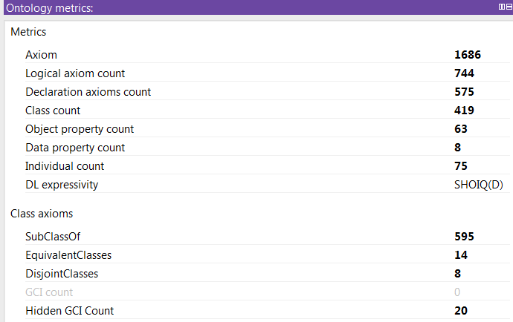

Figure 11: Ontology Metrics

# ontology competency questions

Although we did not specify competency questions at the beginning of the process design, however, the ontology designed could answer several interesting questions. After populating the ontology, as shown below, we can either address some very generic queries or a very specific one.

**Example of very generic queries:**

• What are all networks existing in Barcelona?

Prefix bco <http://www.semanticweb.org/ontologies/BarcelonaCityOntology#>

Prefix cao <http://www.biocenit.cat/ontologies/city_anatomy/CA.owl#>

Prefix dbr <http://dbpedia.org/resource/>

SELECT ?network

WHERE{

?network a cao:Network_infrastructure;

cao:isLocated dbr:Barcelona.

}

• What are the kind of the network?

Prefix bco <http://www.semanticweb.org/ontologies/BarcelonaCityOntology#>

Prefix cao <http://www.biocenit.cat/ontologies/city_anatomy/CA.owl#>

Prefix dbr <http://dbpedia.org/resource/>

SELECT ?network ?networkType

WHERE{

?network a cao:Network_infrastructure;

a??networkType;

cao:isLocated dbr:Barcelona.

}

• What are components of this network?

Prefix bco <http://www.semanticweb.org/ontologies/BarcelonaCityOntology#>

Prefix cao <http://www.biocenit.cat/ontologies/city_anatomy/CA.owl#>

Prefix dbr <http://dbpedia.org/resource/>

SELECT ?network ?networkType ?networkComponent

WHERE{

?network a cao:Network_infrastructure;

a??networkType;

cao:isLocated dbr:Barcelona;

cao:hasElement?networkComponent.

}

• What the network transport ?

Prefix bco <http://www.semanticweb.org/ontologies/BarcelonaCityOntology#>

Prefix cao <http://www.biocenit.cat/ontologies/city_anatomy/CA.owl#>

SELECT ?network ?transportedThingType

WHERE{

?network a cao:Network_infrastructure;

a??networkType;

cao:transports?transportedThing.

?transportedThing a?transportedThingType

}

• What are health care institutions?

Prefix bco <http://www.semanticweb.org/ontologies/BarcelonaCityOntology#>

Prefix cao <http://www.biocenit.cat/ontologies/city_anatomy/CA.owl#>

SELECT ?healthcareInstitution ?healthcareType

WHERE{

?healthcareInstitution a bco:HealthCare\_institution;

a?healthcareType.

}

• What are their locations?

Prefix bco <http://www.semanticweb.org/ontologies/BarcelonaCityOntology#>

Prefix cao <http://www.biocenit.cat/ontologies/city_anatomy/CA.owl#>

SELECT ?healthcareInstitution ?healthcareType ?location ?locationType

WHERE{

?healthcareInstitution a bco:HealthCare\_institution;

a ?healthcareType;

cao:isLocated?location.

?location a?locationType.

}

• What building are used for?

Prefix bco <http://www.semanticweb.org/ontologies/BarcelonaCityOntology#>

Prefix cao <http://www.biocenit.cat/ontologies/city_anatomy/CA.owl#>

SELECT ?builtElement ?builtElementType ?usedFor

WHERE{

?builtElement a cao:Specific_built_domain_element;

a ?builtElementType;

cao:hasUse?usedFor.

}

**Example of very specific queries**:

• Give me component of Gas network myGasNetwork?

Prefix bco <http://www.semanticweb.org/ontologies/BarcelonaCityOntology#>

Prefix cao <http://www.biocenit.cat/ontologies/city_anatomy/CA.owl#>

SELECT ?component

WHERE{

<myGasNetworkUri> a bco:Gas\_network;

cao:hasElement?component.

}

• Give me the street location of Day Care with label "child"?

Prefix bco <http://www.semanticweb.org/ontologies/BarcelonaCityOntology#>

Prefix cao <http://www.biocenit.cat/ontologies/city_anatomy/CA.owl#>

Prefix rdfs: <http://www.w3.org/2000/01/rdf-schema#>

SELECT ?dayCar ?label ?streetLabel

WHERE{

?dayCar a bco:Day_care;

rdfs:label?label;

bco:isLocatedInStreet?street.

?street a bco:Street;

rdfs:label?streetLabel.

Filter (regex(?label, 'child', 'i'))

}

• Give me the primary schools in the district districtURI?

Prefix bco <http://www.semanticweb.org/ontologies/BarcelonaCityOntology#>

Prefix cao <http://www.biocenit.cat/ontologies/city_anatomy/CA.owl#>

Prefix rdfs: <http://www.w3.org/2000/01/rdf-schema#>

SELECT ?primarySchool ?label ?streetLabel

WHERE{

?primarySchool a bco:PrimarySchool;

rdfs:label?label;

bco:isLocatedInDistrict <districtURI>.

}

• Give me the distance between two schools in the same district?

Prefix bco <http://www.semanticweb.org/ontologies/BarcelonaCityOntology#>

Prefix cao <http://www.biocenit.cat/ontologies/city_anatomy/CA.owl#>

Prefix rdfs: <http://www.w3.org/2000/01/rdf-schema#>

prefix geo: <http://www.w3.org/2003/01/geo/wgs84_pos#>

Prefix omgeo: <http://www.ontotext.com/owlim/geo#>

SELECT ?primarySchoolA ?primarySchoolB ?distance

WHERE{

?primarySchoolA a bco:PrimarySchool;

geo:locationA ?locationA;

bco:isLocatedInDistrict?district.

?primarySchoolB a bco:PrimarySchool;

geo:lat?latB;

geo:long?longB;

bco:isLocatedInDistrict?district.

?locationA a geo:Point;

geo:lat?latA;

geo:long?longA;

?locationB a geo:Point;

geo:lat?latB;

geo:long?longB.

BIND( omgeo:distance(?latA,?longA,?latB,?longB) as?distance)

}

• Give me municipalities of Catalonia?

Prefix bco <http://www.semanticweb.org/ontologies/BarcelonaCityOntology#>

Prefix cao <http://www.biocenit.cat/ontologies/city_anatomy/CA.owl#>

Prefix rdfs: <http://www.w3.org/2000/01/rdf-schema#>

SELECT ?cataloniaMunicipality

WHERE{

?cataloniaMunicipality a bco:Municipality;

cao:isLocated bco:catalonia.

}

or

Prefix bco <http://www.semanticweb.org/ontologies/BarcelonaCityOntology#>

Prefix cao <http://www.biocenit.cat/ontologies/city_anatomy/CA.owl#>

Prefix rdfs: <http://www.w3.org/2000/01/rdf-schema#>

SELECT ?cataloniaMunicipality

WHERE{

?cataloniaMunicipality a bco:Catalonia_municipality

}

• Give me the capital of autonomous community?

Prefix bco <http://www.semanticweb.org/ontologies/BarcelonaCityOntology#>

Prefix cao <http://www.biocenit.cat/ontologies/city_anatomy/CA.owl#>

Prefix rdfs: <http://www.w3.org/2000/01/rdf-schema#>

SELECT ?autonumousCommunity ?capital

WHERE{

?autonumousCommunity a bco:Autonomous_community

bco:hasCapital?capital.

}

# CONCLUSION

In this report, we described all our steps followed to try to design a first level of the Barcelona City ontology. Actually, we had a lot of difficulties, during the design process, because there were no competency questions defined neither scenario described. We had to do the work only based on file giving table names without any definition and access to experts. However, the work is still in progress and the ontology produced should be validated by the client in order to ensure that it matches expectations and specificities of the city of Barcelona. The client should also define some scenarios and try to describe them with the ontology to check if the ontology can answer the identified needs.

1. http://www.businessdictionary.com/definition/smart-city.html
2. https://en.wikipedia.org/wiki/Smart_city
3. http://ci.emse.fr/opensensingcity/ns/wp-content/plugins/smartcities/survey_files/vocabs/project_1_0
4. http://www.cptf.cityprotocol.org/dici/Publications%20&%20Ontology/CPA-PR_003_Anatomy_Ontology.pdf
5. https://schema.org/
6. https://w3id.org/seas/
7. https://w3id.org/seas/EvaluationOntology
8. http://www.opengis.net/ont/geosparql
9. http://www.w3.org/2003/01/geo/wgs84_pos#
10. https://www.w3.org/TR/owl-time/
11. http://knowledgecraver.blogspot.fr/2014/07/guidelines-for-using-w3c-time-ontology.html